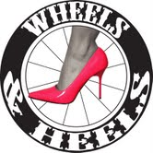

**5:30 – 7:30 pm**

**Tuesday, May 11th**

**Jasper Winery**

**Downtown Des Moines**

*Fashion, fun & fitness for females*

*Celebrity Hosts:*

*Rebecca Meyer - at-home winner of Biggest Loser Season 8*

*Colleen Kelly – Star 102.5 Morning DJ*

*Sponsored by DM Bike Collective*

*Find us on Facebook*