***Sponsored By***

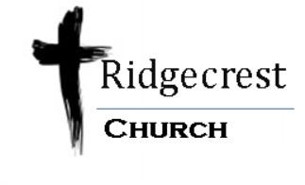

**www.RidgecrestChurch.net**



***Come and enjoy…***

Southwest Iowa’s countryside with lots of fresh air. The first half of the 21 mile ride will have challenging hills while the last half of the ride will be flat to gently rolling hills. This ride will be great training for both BRAN and RAGBRAI.

**The bike ride will start and end at:**

Ridgecrest Church

20245 205th St.

Council Bluffs, IA

51503

**On**

**Saturday June 6th, @ 8:00 a.m.**

**$10 for Individuals B4 5/30 $12 After**

**$20 for Families B4 5/30 $24 After 5/30**

*For more information go to:* [*www.ridgecrestchurch.net*](http://www.ridgecrestchurch.net)

*Make checks payable to Ridgecrest Church &*

*Mail to address above*