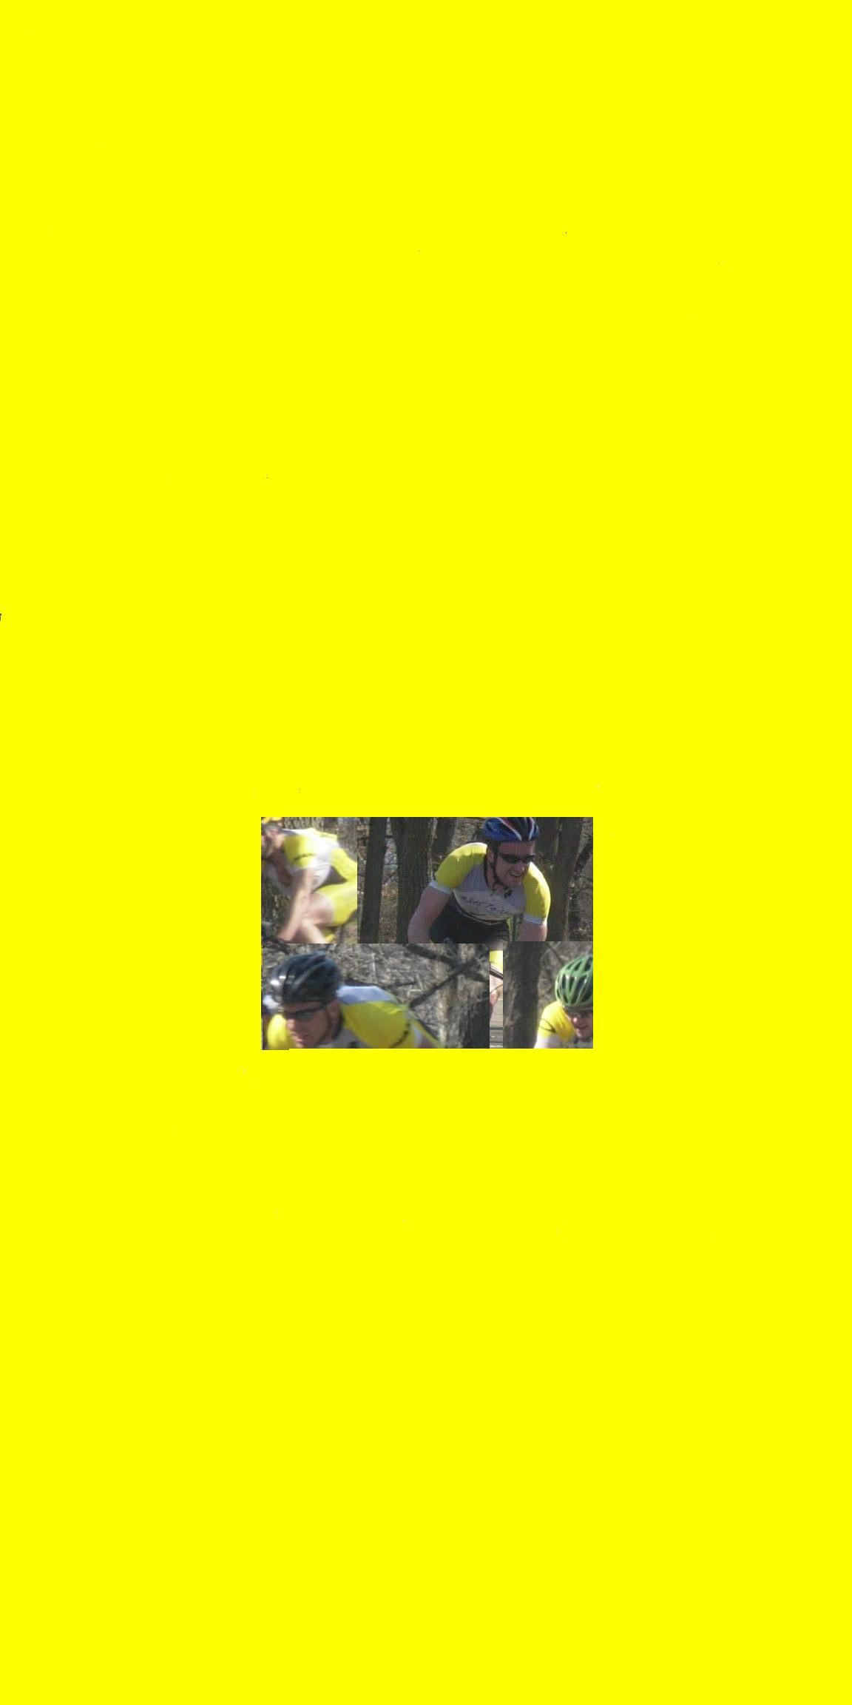
Grinnell Twilight Criterium~August 8th
Hosted by Bikes to You/World of Bikes racing team
Held Under USCF permit # 2009-919
The course is located in beautiful downtown Grinnell. It is approximately one kilometer in length and is ‘L’ shaped with six turns. See the map on back…
pre-register using standard USAC entry sent to address below by 7/31/09 (postmarked)
$3,100 prize list!!!
Categories, registration fee, start times, distance & corresponding prize lists below:
Junior’s*
$18 entry fee, 4 p.m., 30 min. +3 laps, & Merchandise Prizes for 5 places.
Master’s 40 plus*
$25 entry fee, 4:45 p.m., 30 min. +3 laps, & $340 for 5 places.
Women’s 4*
$25 entry fee, 5:30 p.m., 30 min. +3 laps, & $340 for 5 places.
Women’s 1, 2 & 3*
$30 entry fee, 5:30 p.m., 30 min. +3 laps, & $980 for 10 places.
Men’s 4 & 5*
$25 entry fee, 6:15 p.m., 30 min. +3 laps, & $340 for 5 places.
Men’s 1, 2 & 3*
$30 entry fee, 7:30 p.m., 1 hour +3 laps, & $1100 for 10 places.
*Primes from the crowd and local businesses.
Send your registration & entry fee to…
Bikes To You
921 Broad St
Grinnell, Iowa 50112

Contact: Sean Walker 641-236-8600 or wsean3@gmail.com
Sponsors
www.grinnellbank.com

Directions from Des Moines to Grinnell
Take the I-80 E toward DAVENPORT.
0.1 mi
2: Merge onto I-80 E
toward DAVENPORT. 44.5 mi
3: Merge onto IA-146 N via EXIT 182
toward GRINNELL/NEW SHARON. 3.7 mi
4: Turn RIGHT onto 4TH AVE. 0.2 mi
5: Turn LEFT onto BROAD ST. 0.0 mi 