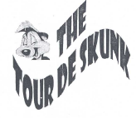
On Saturday, July 8, 2006, the 14th annual Tour de Skunk will commence at OZZY’s in Mingo, Iowa (28 miles east of Des Moines, exit 155 off I-80). Registration for the 40-mile bicycle ride will begin at 9:00 a.m. till 11:30 a.m. Riders climb upon their bikes when they get their fill of breakfast beverages for a relaxing stroll.

The descent to Bondurant will begin at high noon for 10 miles of leisure cycling where the Wooden Nickel will welcome the riding menagerie with abounding fun.

After a well-deserved rest, bikers will stroll 10 miles back to Mingo where OZZY’s will greet them for a second round of fun.

After a belly full of brew, the riders will depart for its next 10 mile destination to Baxter, to enjoy the company of 2 establishments then return to the bike trail for 10 miles back to OZZY’s to enjoy the fine hog roast they provided.

For the $15 registration fee ($20 day of the ride), cyclists will receive the official Tour de Skunk visor and surprise gift with a Hog Roast with all the trimmings.
**Early registrations will be rewarded with your first drink free.**

WHAT: Tour de Skunk

WHERE: OZZY’s
Mingo, IA
641-363-3244

WHEN: July 8, 2006
Registration:
9:00 a.m. – 11:30 a.m.
Delicious breakfast drinks available

WHY: Why Not?
Prepare for RAGBRI

Please make checks payable to:
OZZY’s
115 N Station St.
PO Box 54
Mingo, IA 50168

EXTRAS: Camping available
DJ Music
Beer Garden
ALL PARTICIPANTS MUST BE AT LEAST 21 YEARS OF AGE AND PROVIDE PROPER I.D.

HELMETS ARE STRONGLY RECOMMENEDED.

Tour de Skunk
Official Registration Form

As a rider on the 2006 Tour de Skunk, I know that participation in this event could potentially cause injury. I accept and assume all rids associated with participation in this event and agree to practice road safety. My bicycle is in safe operating condition and I understand that wearing a helmet during the “Tour” is recommended. I understand the foregoing and in consideration of your accepting my entry. I, my Heirs, my personal representatives and anyone entitled to act on my behalf hereby release and discharge assigns and all other sponsors of the Tour de Skunk their agents, representatives and successors from all the liability of any kind that may arise out of negligence or carelessness on the part of the entities named herein.

I am of legal agenda legally competent to execute this statement and that before signing it, I have read and understand its content.

Name:___________________________

Address:_________________________

City:____________________________

State:____________ Zip:___________

Signature:________________________

Date:____________________________

OZZY’s 14th Annual
Bike Ride

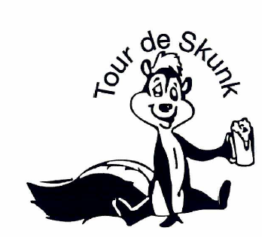

OZZY’s
PO Box 54
Mingo, IA 50168

OZZY’s

TOUR de SKUNK

Annual Bike Ride

Come for the fun

Come for the exercise

Come for the food

and of course

Stay for the party

See you there..

