Bolan Bike Ride

Saturday, September 21, 2019
Bolan Fall Event
Registration begins at 8:00 am, Ride begins at 9:00 am

The small community of Bolan, Iowa (pop. now 17) will put profits toward community improvements. The bike route is mostly flat and loops through the small, friendly communities of Grafton, Carpenter, and St. Ansgar. Come early enough Saturday morning to attend the free-will pancake breakfast at 8:00 am, a fundraiser for the Bolan Schoolhouse & Cultural Center.

Trinity U. M. Church will have a Bazaar in the schoolhouse lower level from 8:00 am – 1:00 pm, and will be serving a scalloped potato & ham luncheon from 11:00 am – 1:00 pm. Visit craft vendors and enjoy the good food and music available in Bolan!

$10 Registration Fee, includes a map, support vehicle, ticket for homemade pie with ice cream afterward.

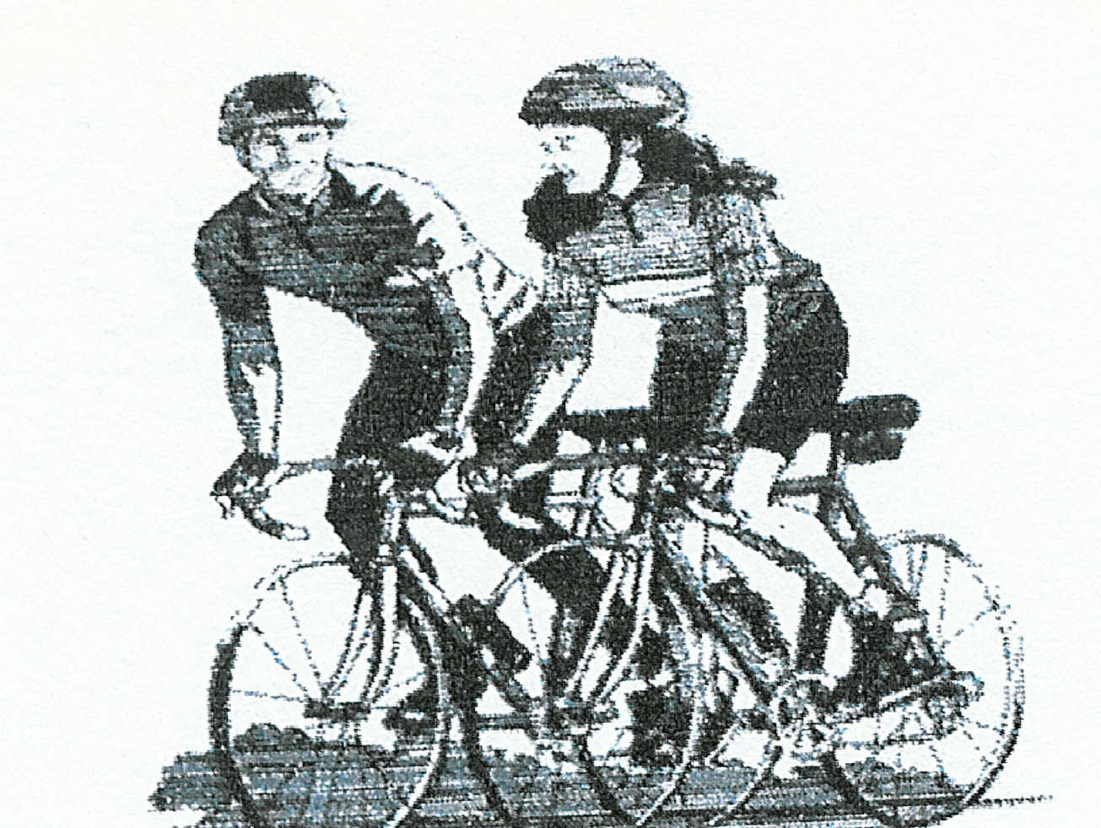
Send to: Questions?
Community of Bolan, Iowa Call 641-845-2677
c/o Lori Willert 641-903-9472 (cell)
4211 Tulip Lane Email lwillert@wctatel.net
Kensett, IA 50448

If bad weather, listen to KIA FM 93.9 or KGLO AM 1300 for announcements.

One form per person please

Name: __________________________________________
Address: ________________________________________ Age: ________
City: ____________________________________________ State: _______ Zip: __________

May we send registration form by email next year? Email: _____________________________________________________________
Please write a very legible email address

Check the route you plan to take:
_____ 12-mile Grafton loop
_____ 26-mile Carpenter, Grafton
_____ 40-mile Carpenter, St. Ansgar, Grafton
_____ 52-mile Carpenter, Grafton loop twice!

Fee: $ 10
Total Enclosed: $ ______________ Check payable to: Bolan Community Fund

Disclaimer: I hereby agree not to hold the members of the sponsoring organization liable for any damages or bodily injury I may incur during my voluntary participation in this event. I agree to obey all traffic regulations and use “cyclist courtesy”. I know that wearing a bicycle helmet is strongly recommended.

_______________________________________________________
Signature (and parent or guardian if under 18)

